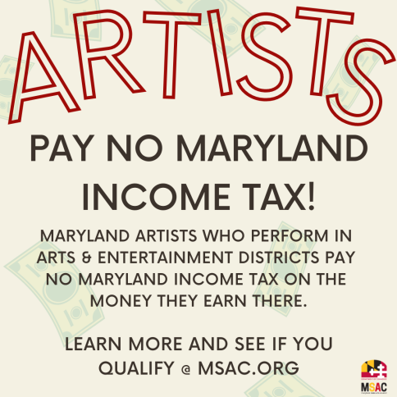
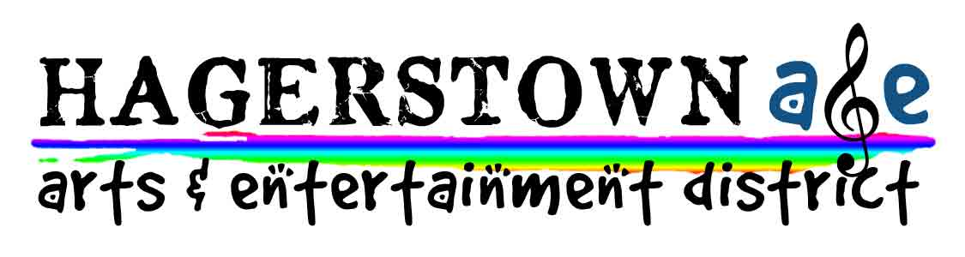

Dear Performing Artist,

Thanks for performing in Hagerstown’s Arts & Entertainment District, a state designation conferred by the Maryland State Arts Council and the Department of Commerce.

One of the perks of performing in our A&E District is that you may be eligible for a Maryland Income Tax Subtraction Modification (ITSM). We are not accountants, but we can provide the following information that may be beneficial to you when you file your Maryland state taxes. You should confer with your tax preparer about this benefit in more detail.

- The ITSM is for income that Maryland residents earn while performing (or engaging in another qualifying artistic activity) in one of the state-designated Arts & Entertainment Districts in the state.
- Only Maryland residents are eligible for the ITSM.
- To qualify, a residing artist must:
  - own or rent residential property in Maryland;
  - conduct an arts business (which includes performing music) in an A&E district;
  - earn income from the performance, sale, production, or publication of an artistic work, produced individually or collaboratively within an A&E district.
- The incentive is available only to individuals being paid as independent artists and sole proprietor businesses (and not if you are being paid as a salaried employee of the band).
- To receive this benefit, an eligible artist must file a completed 502AE form with their Maryland individual income tax return. Find current forms at https://www.marylandtaxes.gov/

For more information about the ISTM benefit, please visit https://msac.org/programs/arts-entertainment-districts.

For more information about Hagerstown’s Arts & Entertainment district, please visit https://www.hagerstownmd.org/157/Arts-Entertainment-District.

We hope you’ll be back to perform in the Hagerstown A&E District again!

Please contact me with any questions.

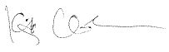
Kitty Clark
Community Events Coordinator
kclark@hagerstownmd.org
301-766-4188

